My codes are based on the use of database tables via sqlite in python.

Actually the database file has been created and the result is based on the data there.

When there is no existing database, below is how I run it:

First, **we need to change the directory(path) in every python code file** so that the codes would proceed correctly as you wish.( i.e. "C://Users//Chenxi//Desktop//examContent//coding-data-exam//yld_data//US_corn_grain_yield.txt" in the following picture):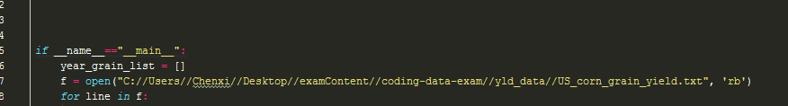

Second, we need to run the file in the following order:



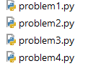

**Finally,** the code solution to **problem 4** requires **installing the numpy package** which helps getting **the pearson correlation**.

As you run them through one by one, the database would be updated as well, please ignore all the generated text in the dialog box if there is any, as they are for my test purpose.

**Thank you for your patience at reading the manual. Please let me know if you have questions.**